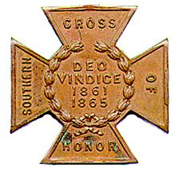
The SOUTHERN CROSS
Newsletter of the Sterling Price Camp #145
Sons of Confederate Veterans
St. Louis, MO
June 2017

Charge to the Sons
“To you Sons of Confederate Veterans, we will submit the vindication of the cause for which we fought. To your strength will be given the defense of the Confederate soldier’s good name, the guardianship of his history, the emulation of his virtues, the perpetuation of those principles he loved and which made him glorious and which you also cherish. Remember it is your duty to see that the true history of the South is presented to future generations.”
General Stephen Dill Lee

Camp Officers

Commander – Ray Cobb
First Lt. Commander – Bob Kennedy Second Lt Commander – Bill Napier
Sgt. at Arms – Dan Maltman Adjutant – Chuck Knight

Camp CALENDAR

Saturday, June 3, 2017 Sterling Price Camp meeting
Program: “Logistics in the Civil War” presenter: Maj. Douglas Gifford, USA, Ret.
12:30 PM Social Time 1:00 PM Meeting Starts

July 18-23, 2017 SCV National Meeting, Memphis, TN

October 7, 2017 150th Anniversary Observance of the death and burial of former Governor and General (CSA) Sterling Price, and his daughter-in-law, wife of Celsus Price, and their baby son. Bellefontaine. Cemetery
October ?, 2017 The SCV will be breaking ground in October
on THE NATIONAL CONFEDERATE MUSEUM at Elm Springs, TN

Please join us. All monthly meetings are held at the Schnuck’s Supermarket at 12756 Olive Street Boulevard in Creve Couer. It is approximately 1.9 miles west of I-270 on the south side of the street.

See the details under Camp News. Are you interested in presenting at a program, or know of someone who is in 2017, contact Bill Napier, our Program Director.

Camp News
The location of the monthly meeting for the Sterling Price Camp has changed to 12756 Olive Boulevard
in the “Back Stage” Room. Directions from the camp adjutant:

Take the Olive Boulevard exit off INT 270 and go west about one mile until a half a block after you pass Mason Road, then turn left into Bellerive Plaza and at the stop sign make another slight left into the Schnucks parking lot. We have been asked to park near the Firestone Tire Store at the left end of the lot as you face the store. The “Back Stage” room is located inside the front part of the store, on the Firestone store side, about 40 feet beyond the self-checkout counters. Please note: There is prepared food available at the Deli. ONLY FOOD PURCHASED AT SCHNUCKS MAY BE BROUGHT INTO THE ROOM.

Paste the following URL into your browser for a better view:
https://www.google.com/maps/place/12756+Olive+Blvd,+Creve+Coeur,+MO+63141/@38.6787722,-90.4730394,15z/data=!4m5!3m4!1s0x87df2d14080e1c3d:0x44b4099275a4e602!8m2!3d38.6782487!4d-90.4731145?hl=en
At the April meeting, guest Edna Dieterel made a pitch on a planned upcoming event later this year, October 7th, to commemorate the 150th Anniversary of the death and burial in Bellefontaine cemetery of former Governor and General (CSA) Sterling Price, and his daughter-in-law, wife of Celsus Price, and their baby son all who died on the same day and are buried near Gen. Price in Bellefontaine. Edna is looking for volunteers to participate in the re-enactment in period clothing. We also need a crowd to attend. If you can help her, please do!!!!
The SCV will be breaking ground in October on THE NATIONAL CONFEDERATE MUSEUM at Elm Springs. There will be a plaque at the museum listing all the "founders" that give $1000 toward the museum fund. That’s’ a lot of money so would you consider sending $10, $25 or even $50? The information is in the latest Confederate Veterans magazine. It is also available through the web site.

Confederate Memorial Foundation Association - Dues are $10/year for General Membership, $25/year for Contributing Membership and $55/year for Sustaining Membership. Help support the efforts to maintain the Confederate Veterans Home in Higginsville. Mail to: CMFA, Inc., P.O. Box 332, Higginsville, MO 64037-0332.

Missouri State Guard flags – Here’s your opportunity to be able to fly the flag that was carried by the Missouri State Guard as they defended the state from the unlawful war declared on it by the Federal government in Washington, DC. Those men carried this flag as they marched, fought and died to protect their homes and families from the Federal army under the warmonger Brigadier General Nathaniel Lyon, At Carthage, at Oak hills and over the siege and capture of the fortifications at Lexington she flew and now own your own 3” x 5” replica. They can be purchased via mail order at the price of only $50, which includes taxes and shipping. Send orders to John Moloski, Burnt District Press, P.O. Box 207, Harrisonville, MO 64701. To contact John, call (816) 668-5862.

Southern Cross of Honor Sales - The Moses Wood Camp 125 is selling 26” X 12”crosses made from a composite resin material (similar to a bowling ball) and pigment dyed black. The crosses come with a metal rebar molded into the tang of it making it ready to place upon arrival. The crosses are $30 plus $5 packaging and handling as well as price pf parcel post to your door. Discounts are available on shipping when more than 1 cross is purchased. Contact: Robert E. Little at rmrel1948@yahoo.com. Make checks payable to: Moses Wood Camp 125 SCV, 109 S. Johnson St., Gaffney, SC 29340.

Sterling Price Camp Meeting Minutes
Sunday, April 1st, 2017 at Schnucks

1. The meeting was called to order by Commander Ray Cobb at 3:00 PM.
2. The invocation was given by 2nd Lt. Commander Bill Napier
3. The Pledge of Allegiance was led by Past Commander Jim England
4. The Salute to the Confederate Flag was led by Eastern Division Commander Mike Harris.

5. Reading of the Last Meeting’s Minutes – A motion was made by 2nd Lt. Commander Bill Napier, then
seconded and passed to dispense with the last meeting’s minutes as they were included in the Camp Newsletter.
6. Adjutant’s Report: A motion was made by 2nd Lt. Commander Napier then seconded and passed to
dispense with the reading of the Financial Report.
7. Announcements, Reports and Information Passed to the Camp:
A. 2nd Lt. Commander Bill Napier gave a report on the results of the “Swap Meet” held at Jefferson Barracks in late March. He indicated there wasn’t a good turn-out and that he only made a small amount on sales. He plans to contact Michael Pierce, the Swap Meet organizer, to persuade him to change the date of the annual event to a later date in the spring, hoping for a better turn-out.
B. Guest Edna Dieterel made a pitch on a planned upcoming event later this year, October 7th, to commemorate the 150th Anniversary of the death and burial in Bellefontaine cemetery of former Governor and General (CSA) Sterling Price, and his daughter-in-law, wife of Celsus Price, and their baby son all who died on the same day and are buried near Gen. Price in Bellefontaine. Edna is looking for volunteers to participate in the re-enactment in period clothing.
8. There were no committee reports.
9. New Business: None
10. Program for the Meeting: The original program scheduled for this meeting “The 1862 River War” which
was to be given by St. Louis City Librarian Tom Pearson who had to cancel due to a scheduling conflict and will give his report at a later date. However, Program Chairman and Second Lt. Commander Bill Napier stepped in and gave a very interesting and informative talk on “Little Egypt” the southern parts of Illinois and Indiana whose populations at the beginning of the War Between the States showed very strong support toward the Confederacy. It was obvious that Compatriot Napier had done a lot of research and study on the subject “Little Egypt” from his presentation.
11. Other Announcements before Closing: The Speaker for the next meeting, Saturday May 6th will be Ret.
U.S. Army major Douglas Gifford whose topic will be: “Logistics in the civil War”. Also, three Camp members will be traveling to Vicksburg, Miss. for the re-dedication of the Missouri War Between the States Monument in the Vicksburg National Military Park on U. S. Memorial Day, Monday May 29^{th.} It has recently undergone restoration. The Governor of Missouri, Eric Grietens, will also be in attendance.
12. The singing of Dixie: - was led by Commander Ray Cobb.
13. Benediction: Compatriot and Past Commander Jim England closed the meeting with a heartfelt reading
of the poem “The Southern Dead”.

HERITAGE PONDERINGS FROM THE INTERNET
Bottom of Form

WHY DEMOCRATS WANT YOU TO FORGET THE CONFEDERACY

Exclusive: Joseph Farah spills dirty little secret behind left's assault on statues, flags, memorials
Read more at http://www.wnd.com/2017/05/why-democrats-want-you-to-forget-the confederacy/#icvG8ce1jfjW2oPU.99
JOSEPH FARAH
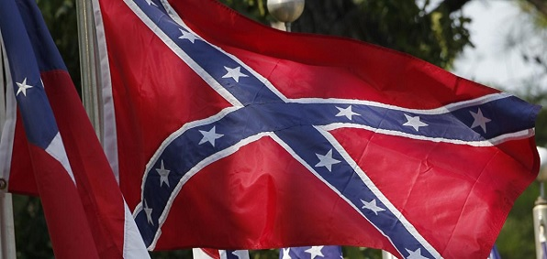

Have you noticed the movement to remove statues, memorials, flags and markers that commemorate the historical reality of the Confederacy in America? Earlier this month, we saw another vivid example of this when New Orleans removed the last of three statues of Confederate heroes – Robert E. Lee, Jefferson Davis and P.T. Beauregard.
It’s happening in dozens of states – not just Southern. Some of these monuments have been around for nearly 150 years. What’s this new war on the Confederacy all about?
I have a theory. I don’t think it explains the phenomenon in its entirety. But I definitely think it’s part of the explanation for the scorched-earth policy against American history, the attempt to erase any historical vestige of the most costly war in our history.
First, you will notice that Democrats are nearly always at the forefront of this kind of activity. Why would that be? Could it be because they are embarrassed and ashamed of their party’s own history?
You see, Jefferson Davis, the only president of the Confederacy, was a Democrat. In fact, for 50 years after the War Between the States, the white South was dominated almost entirely by the Democratic Party. White Democrats ran the South during the war, through the Jim Crow days of segregation and right up until the early 1960s.
Not a single Democrat in that era ever suggested destroying statues of Confederate heroes, taking down Confederate flags or toppling monuments memorializing the Confederacy.
What’s more, the Ku Klux Klan would have discouraged such demolition. And the Ku Klux Klan was the military arm of the Democratic Party. As you can learn in Ben Kinchlow’s amazing book, “Black Yellow Dogs,” the Klan didn’t just lynch blacks, they also strung up plenty of white Republicans.
Kinchlow is hardly alone in reporting this. Historian Eric Foner, author of “A Short History of Reconstruction,” summed it up thusly: “In effect, the [Ku Klux] Klan was a military force serving the interests of the Democratic Party, the planter class, and all those who desired the restoration of white supremacy. Its purposes were political in the broadest sense, for it sought to affect power relations, both public and private, throughout Southern society. It aimed to destroy the Republican Party’s infrastructure, undermine the Reconstruction state, re-establish control of the black labor force and restore racial subordination in every aspect of Southern Life.”
What occurs to me as I read these stunning words is how successful the Democratic Party has actually been in achieving those goals over the last 130 years. Today, it not only has “control of the black labor force,” it has control over the black vote – the very vote it sought to deny for most of those 130 years after the War Between the States.
Here’s some more from Foner, who tells the story most Americans have never heard – that the Klan’s war was not just against blacks; it was against Republicans:
Violence was typically directed at Reconstruction’s local leaders. As Emmanuel Fortune, driven from Jackson, County, Florida, by the Klan, explained: “The object of it is to kill out the leading men of the Republican Party … men who have taken a prominent stand.”
Jack Dupree, victim of a particularly brutal murder in Monroe County, Mississippi – assailants cut his throat and disemboweled him, all within sight of his wife, who had just given birth to twins – was “president of a Republican club” and known as a man who “would speak his mind.”
On occasion, violence escalated from the victimization of individuals to wholesale assaults on the Republican Party and its leadership. In October 1870, after Republicans carried Laurens County, in South Carolina’s Piedmont belt, a racial altercation at Laurensville degenerated into a “negro chase” in which bands of whites drove 150 freedmen from their homes and committed 13 murders. The victims included the newly elected white probate judge, a black legislator and others “known and prominent as connected with politics.”
Founded in 1866 as a Tennessee social club, the Ku Klux Klan spread into nearly every Southern state, launching a “reign of terror” against Republican leaders black and white. Those assassinated during the

campaign included Arkansas Congressman James M. Hinds, three members of the South Carolina legislature, and several men who had served in constitutional conventions. In Louisiana, even moderate ex-Governor Hahn by October complained that “murder and intimidation are the order of the day in this state.” White gangs roamed New Orleans, intimidating blacks and breaking up Republican meetings. In St. Landry Parrish, a mob invaded the plantations, killing as many as 200 blacks. Commanding Gen. Lovell Rousseau, a friend and supporter of the president, refused to take action, urging blacks to stay away from the polls for self-protection and exulting that the ‘ascendance of the negro in this state is approaching its end.”
I could go on and on with this well-documented history, but you get the point.
Today we think of the Democratic Party as the champion of black Americans, more than 90 percent of whom support the party. But it was the other way just 60 or 70 years ago in America. The Republican Party was their party – the party of Lincoln, the party of desegregation, the party of abolition.
What changed?
Democratic Party tactics.
It was President Lyndon Baines Johnson who got the idea of the Democrat Party becoming the “champion” of black Americans by enticing them into dependency through welfare-style programs.
This is why the late Martin Luther King Jr. was a Republican. He understood the history. He recognized who represented political allies and political foes.
Now do you understand why Democrats have a special desire to stamp out, erase and eradicate all history about this period?
They simply don’t want their cover blown!

After the Confederates, Who's Next?
https://townhall.com/columnists/patbuchanan/2017/05/26/draft-n2331882
Posted: May 26, 2017 12:01 AM
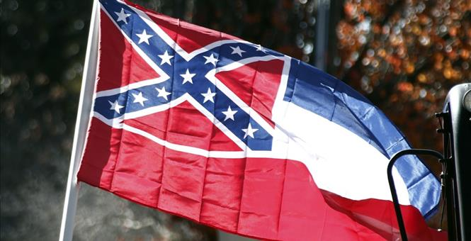
On Sept. 1, 1864, Union forces under Gen. William Tecumseh Sherman, victorious at Jonesborough, burned Atlanta and began the March to the Sea where Sherman's troops looted and pillaged farms and towns all along the 300-mile road to Savannah. Captured in the Confederate defeat at Jonesborough was William Martin Buchanan of Okolona, Mississippi, who was transferred by rail to the Union POW stockade at Camp Douglas, Illinois.

By the standards of modernity, my great-grandfather, fighting to prevent the torching of Georgia's capital, was

engaged in a criminal and immoral cause. And "Uncle Billy" Sherman was a liberator.

Under President Grant, Sherman took command of the Union army and ordered Gen. Philip Sheridan, who had burned the Shenandoah Valley to starve Virginia into submission, to corral the Plains Indians on reservations.

It is in dispute as to whether Sheridan said, "The only good Indian is a dead Indian." There is no dispute as to the contempt Sheridan had for the Indians, killing their buffalo to deprive them of food. Today, great statues stand in the nation's capital, along with a Sherman and a Sheridan circle, to honor these most ruthless of generals in that bloodiest of wars that cost 620,000 American lives.Yet, across the South and even in border states like Kentucky, Maryland and Missouri, one may find statues of Confederate soldiers in town squares to honor the valor and sacrifices of the Southern men and boys who fought and fell in the Lost Cause.

When the Spanish-American War broke out, President McKinley, who as a teenage soldier had fought against "Stonewall" Jackson in the Shenandoah and been at Antietam, bloodiest single-day battle of the Civil War, removed his hat and stood for the singing of "Dixie," as Southern volunteers and former Confederate soldiers paraded through Atlanta to fight for their united country. My grandfather was in that army. For a century, Americans lived comfortably with the honoring, North and South, of the men who fought on both sides.

But today's America is not the magnanimous country we grew up in. Since the '60s, there has arisen an ideology that holds that the Confederacy was the moral equivalent of Nazi Germany and those who fought under its battle flag should be regarded as traitors or worse. Thus, in New Orleans, statues of Jefferson Davis, president of the Confederate States of America, and General Robert E. Lee were just pulled down. And a drive is underway to take down the statue of Andrew Jackson, hero of the Battle of New Orleans and president of the United States, which stands in Jackson Square.

Why? Old Hickory was a slave owner and Indian fighter who used his presidential power to transfer the Indians of Georgia out to the Oklahoma Territory in a tragedy known as the Trail of Tears. But if Jackson, and James K. Polk, who added the Southwest and California to the United States after the Mexican-American War, were slave owners, so, too, were four of our first five presidents. The list includes the father of our country, George Washington, the author of the Declaration of Independence, Thomas Jefferson, and the author of our Constitution, James Madison. Not only are the likenesses of Washington and Jefferson carved on Mount Rushmore, the two Virginians are honored with two of the most magnificent monuments and memorials in Washington, D.C.

Behind this remorseless drive to blast the greatest names from America's past off public buildings, and to tear down their statues and monuments, is an egalitarian extremism rooted in envy and hate. Among its core convictions is that spreading Christianity was a cover story for rapacious Europeans who, after discovering America, came in masses to dispossess and exterminate native peoples. "The white race," wrote Susan Sontag, "is the cancer of human history."

Today, the men we were taught to revere as the great captains, explorers, missionaries and nation-builders are seen by many as part of a racist, imperialist, genocidal enterprise, wicked men who betrayed and eradicated the peace-loving natives who had welcomed them. What they blindly refuse to see is that while its sins are scarlet, as are those of all civilizations, it is the achievements of the West that are unrivaled. The West ended slavery. Christianity and the West gave birth to the idea of inalienable human rights.

As scholar Charles Murray has written, 97 percent of the world's most significant figures and 97 percent of the world's greatest achievements in the arts, architecture, literature, astronomy, biology, earth sciences, physics, medicine, mathematics and technology came from the West. What is disheartening is not that there are haters of our civilization out there, but that there seem to be fewer defenders.

Of these icon-smashers it may be said: Like ISIS and Boko Haram, they can tear down statues, but these people could never build a country. What happens, one wonders, when these Philistines discover that the seated figure in the statue, right in front of D.C.'s Union Station, is the High Admiral of the Ocean Sea, Christopher Columbus?

A JERSEY GIRL DEFENDS ROBERT E. LEE

Why Confederate monument removal is a questionable mission for all Americans, black and white.
May 26, 2017
Danusha V. Goska
http://www.frontpagemag.com/fpm/266791/jersey-girl-defends-robert-e-lee-danusha-v-goska

Forgive me Danusha for using the entire article. But you get all the credit.
Share to Facebook17Share to TwitterShare to More15Share to Print
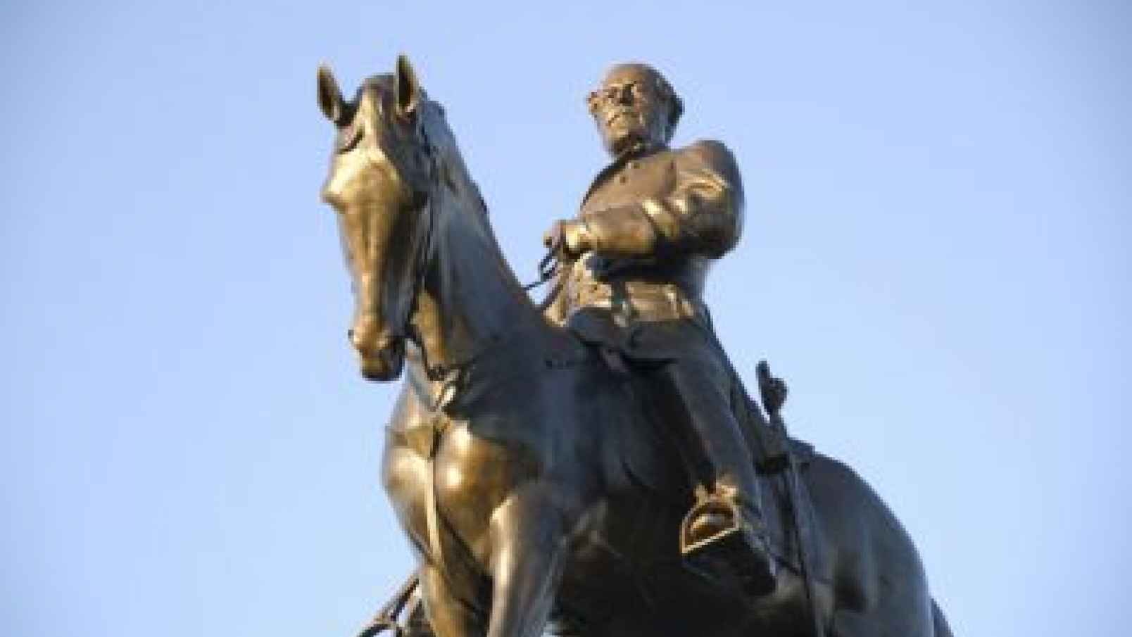
Life is funny. Turn back the clock and tell twenty-year-old me, "Girl, someday you are going to defend Confederate General Robert E. Lee." That Jersey girl would dismiss you with a short, sharp, two-syllable sentence, a sentence I cannot reproduce in a family-friendly essay. When I was young, I felt about the South what all liberal people around me felt about the South. "Ew."

There's a process that sociologists call "othering." One attributes positive qualities to oneself, and attributes the opposite of those qualities to the group one "others." I knew that people from the New York metro area were the smartest in the country. People from the South were stupid, and probably infested with cooties. The mere thought of Southern food was nauseating. What did they eat? Possum and cornpone. The Beverly Hillbillies ate possum. Truth to tell, I had no idea (and still have no idea) what "cornpone" is. If I ever moved so much as one toe into Dixie, I'd be arrested by a cop speaking with a thick drawl and wearing mirrored sunglasses. I'd receive no Constitutional protection and would rot in jail where I'd have to sing Negro spirituals I knew by heart from listening to my mother's LPs. All morality stopped at the Mason-Dixon Line. They did bad things down there. Dark, twisted things. While playing the banjo!

Remember that famous slap that Sidney Poitier delivered to the face of a Southern white man in the groundbreaking 1967 film, In the Heat of the Night? My mother and I witnessed that slap together in a movie theater. She loved seeing American oppression topple. She was a big fan of Paul Robeson, an African American Jersey boy who had made it all the way to Mother Russia.

I vividly remember a journalistic discussion during the Civil Rights Era. It went something like this: "When we report violent crime, we often identify the race of the criminal. By doing so, we associate the words 'black' and 'criminal' in the mind of our audience. We want to eliminate that association. Therefore, in future news reports of violent crime, we will not mention the race of the criminal." A similar discussion took place, a few years later, around the words "Palestinian terrorist," and then, later, "Muslim terrorist." Journalists decided that they would just use the word "terrorist." Later even that word, "terrorist," became suspect. It was changed to "militant."

A very different policy reigned when it came to the South. Journalists, scholars, artists, and ministers were eager to use their power with language to brainwash us into conflating the South, Southern culture, and Southerners with racism. As Shelby Steele has described, in a rapidly secularizing America, racism took the

place that sin used to occupy. You could, like Bill Clinton, commit a mortal sin – adultery – and still be president. You couldn't, though, as Eisenhower and LBJ allegedly did, be thought to use the N-word and survive politically. The South became our national cesspit of sin.

Thousands of years ago, following a lengthy and painstaking ritual described in the Mishnah, Jewish priests laid all the sins of the community on a goat. They adorned this goat with a scarlet, woolen thread, lead into him wilderness, and threw him off a cliff. The high priest prayed, "Oh Lord, I have acted iniquitously, trespassed, and sinned before you. I and my household … Oh Lord, forgive the iniquities, transgressions, and sins … On this day he will cleanse you from all your sins."

Modern, secular liberals, no less than ancient Israelites, believe in sin. That sin is racism. Unlike the ancient Israelites, liberals do not confess their own sins. They confess others' sins. Liberals, obeying urges even more primitive than those described in Leviticus, select the South as the goat. At least the ancient Israelites confessed their own sins before sacrificing a goat. Remember: othering is all about creating and then emphasizing opposites. When a liberal stands up in public and scapegoats the South and Southerners as racist, that liberal is publicly identifying himself as not racist, as, in fact, the opposite of racist – as pure. This scapegoating rewrites history, and erases any slaves that lived up North. Liberals locate all sin in the sin of racism, and locate all racism in the South. More on this selective outrage, below.

Metonymy is one linguistic tactic that serves the scapegoating of the South. In metonymy, we take one property we associate with a larger idea, and use that property to indicate the larger idea. For example, we use the words "Wall Street" to refer to all bankers."Birmingham," the name of a Southern city, site of a 1963 church bombing; "redneck," a word for a poor Southern white whose neck is red from working in the fields; "mint julep" or "moonlight and magnolia," which now refer to improper romanticization of the antebellum South, and denial of the harshness of slavery; "cornpone," which has come to mean "rustic, unsophisticated;" Bluegrass banjo music, which filmgoers inevitably associate with the anal rape in Deliverance: all these previously neutral words and cultural markers are now metonyms. We can use them as powerful, shorthand invocations of demonization and scapegoating of the entire South, every Southerner, and every aspect of Southern culture, from food to music to people.

Metonyms bypass rational thought. They immediately set off little explosions inside our brains. We feel emotions before we can think thoughts. Mere mention of the word "Birmingham" does not bring to mind a city with a history and decent citizens who are more or less just like us. Mention of "Birmingham" immediately brings to mind the horror of the 1963 church bombing that took the lives of four little girls. In our minds, when we hear the metonym "Birmingham," it is always 1963, and black lives are always being sacrificed by powerful white supremacists.

In their defiant song "Sweet Home Alabama," which tried to take on and defeat scapegoating of the South, Lynyrd Skynyrd mentioned Birmingham, but their song was not powerful enough to rewire our brains. When we hear "Los Angeles" we don't immediately think of the on-camera torture and attempted murder of white truck driver Reginald Denny at the hands of black criminals. When we hear "Knoxville" we don't think of the torture-murder of Channon Christian and Christopher Newsome. When we hear "Birmingham" we do think of the bombing. The South has lacked the cultural clout to defeat its scapegoating, and the reduction of its cultural markers to metonyms that evoke images of racism and racists.

How did I get here? How did I mature from a brainwashed girl who thought the South was the geographic embodiment of evil into a woman who resists demonization and scapegoating of the South? I went to graduate school. One of the first things my professors and peers learned about me is that I am working class, Catholic, and Polish American. These are not good things to be in graduate school. I was assumed to be stupid, unclean, and racist – because of my class, religion, and ethnicity. What I thought of Southerners, and for the same mental processes of demonization and scapegoating, my grad school betters thought of me.

In the same way that markers of Southern culture are used as code to communicate "racism," markers of my culture were used to communicate the same sin. Words like "hardhat," "blue collar," "factory worker," "church-going," and even just the word "Poland," were not neutral communications of actual realities in all their complexity. These words were metonyms used to scapegoat and demonize. Being treated like a leper in grad school provided me with many "Aha" moments. Here's one. I was at a party in Berkeley, chatting with a new acquaintance. We were hitting it off. I asked her name. I recognized it; she was a potential employer to whom I had sent my resume. This liberal Berkeley professor said, without any shame at all, "Oh, you're her? I got your

resume a while back. I took one look at your name at the top of the resume and threw it away. I immediately imagined some surly, stupid, heavily-accented Eastern European." She laughed. She thought it was funny. Here she was discovering that I could eat with a knife and fork.

Yes, yes, yes, you may be thinking. Americans do stereotype the South. So what? There are good reasons for removing Lee's statues.

Okay, let's look at some cold, hard facts. The American Institute of Architects list the Jefferson Memorial in Washington, DC fourth on their List of America's Favorite Architecture. In 2016, the Jefferson Memorial welcomed three and a half million visitors. It is the third most popular presidential memorial, more visited than Mount Rushmore. My visit was a religious experience. I read, "I have sworn upon the altar of God eternal hostility against every form of tyranny over the mind of man." It was as if I felt Jefferson's immediate presence. In his courageous commitment to human freedom, Jefferson was my ally and kin. He remains my favorite Founding Father. Without him, I do not see my America coming to be.

The neoclassical Jefferson Memorial is patterned after the architecture of Monticello, a slave plantation. When he was 44, Thomas Jefferson, historians say, and I believe, raped his 14-year-old slave, Sally Hemings, his deceased wife's half-sister. Hemings bore six children to Jefferson, all of them slaves. This Jefferson is my enemy.

If we employ a scale that measures human failings, and apply that scale's report to which monuments we keep and which monuments we gauge out, that coldly rational scale offers us no reason to keep the Jefferson Memorial and tear down a statue of Robert E. Lee.

Andrew Carnegie is the eponym of New York's Carnegie Hall. Carnegie made much of his immense fortune off Bohunks like me. During the 1892 Homestead strike, Carnegie's people murdered my people. One account reports, "The Hungarians, Slavs, and Southern Europeans … were a savage and undisciplined horde, with whom strong-arm methods seemed at times indispensable." Savage and undisciplined. Use us, defame us, and kill us. This history hurts me. I feel no need to tear down Carnegie Hall. Carnegie gave away 90% of his fortune – $80 billion in today's dollars. Carnegie funded three thousand libraries. I love libraries. The world is a complicated place. The world's complication is larger than my pain.

This is what maturity demands: that I recognize that the unique heroism of Thomas Jefferson gave me my country, and that that same man was imperfect in the way that other men of his time were imperfect. John Adams, his contemporary, utterly rejected slavery. I admire Adams, but he did not give me the Declaration of Independence.

I know a man, Otto, who has had to travel this route to maturity in his own life. In unguarded moments, Otto, perhaps without even realizing it, has expressed real love and admiration for his father. His father was strong, hard-working, and a skilled iron worker. Otto's father abused him in ways too painful to detail here. In fact, Otto's father was a Nazi. Otto writes about the unique challenges of coming to term with an abusive, Nazi father in his essay "Ripples of Sin."

Otto's father was unique in his life. No father, no Otto. Thomas Jefferson is unique to me. No Jefferson, no America. These men's unique gifts demand that we react not only to the horror we feel at their crimes, but, rather, that we incorporate everything we feel about these men into our final analysis. When we do this, we mature. We see not only Jefferson and Otto's dad in new and deeper ways. We also see ourselves in the only true source of light we can shine on ourselves if we want to be grown-ups. In my worst moments, I have been as bad as Jefferson in his worst moments. I want to overcome what is worst in me and live up to what is best in me. Knowing the dark truths about Jefferson, and feeling an overall tingle and tearing up when I think about the words in his memorial, bring me closer to being my best self.

What about Robert E. Lee? Is he unique in some way that requires us to mature to the point where we can tolerate his statue in our midst? Lee is not important to me, a Yankee, but Lee is uniquely important for Southerners.

Lee was "The Marble Man," one who disciplined himself ruthlessly in order to perform with the perfection that he demanded of himself and others. He shone at West Point and earned accolades in the Mexican-American War.
His immediate family and in-laws included people who broke the law to educate slaves, and raised money to free slaves. In an 1856 letter to his wife, Lee wrote, "slavery as an institution, is a moral & political evil in any Country. It is useless to expatiate on its disadvantages. I think it however a greater evil to the white man than to the black race, & while my feelings are strongly enlisted in behalf of the latter, my sympathies are more strong for the former."

In an 1861 letter to his son, Lee wrote, "As an American citizen, I take great pride in my country … I can anticipate no greater calamity … than a dissolution of the Union. It would be an accumulation of all the evils we complain of, and I am willing to sacrifice everything but honor for its preservation. I hope, therefore, that all constitutional means will be exhausted before there is a resort to force. Secession is nothing but revolution."

After being invited to serve the Union army, Lee paced back and forth during the day and prayed at night. He could not take up arms against Virginia, his home state. He commanded Confederate forces, and became the bloodiest general in US history, losing the largest percentage of his men. The carnage saddened him. Lee "aged twenty years in twenty months." When loved ones saw recent photos, they thought it could not be he. He suffered a heart attack in 1863; some theorize this affected his performance at Gettysburg. In spite of ill health, he soldiered on to the bitter end.

Anyone with any human depth can only reflect when contemplating Lee's biography: what would I have done? What would you do if you had sworn to uphold the Constitution, and given your life to being a perfect patriot and soldier, and your home state, imperfect as it was, was invaded? We must acknowledge that it would be a damnable choice guaranteeing nightmares either way.

The irreconcilable facts of Robert E. Lee's biography – patriot, traitor; compassionate patriarch who lead a record of young men to their deaths – emerge from the chaotic, multidimensional, whirling fan of real life. Liberals demand that we view the South and indeed America only through the lens of condemnation. Real life shatters their command. Life's complexity emerges in shards that we must rearrange as our compassion and depth allows.

I don't know, but I do guess, that many Southerners who cherish Robert E. Lee's statues do so for the following reasons. Their conquerors continue to depict them as lowlife scum. In him, they see an honorable man who excelled at everything he put his hand to before the Civil War. They see a man who was not an unambiguous champion of slavery but rather, like all of us, he was a person who was born into an unjust world he could not single-handedly fix. A man who hoped that the passage of time would resolve the world's problems. They see a man whose decision to fight was informed primarily by his attachment to his home.

Look, I'm not a Southerner. Why should I get worked up about liberal discourse about statues of Robert E. Lee? Because that discourse is a microcosm of how the left insists we talk about America. Leftists in power distribute glasses through which I am ordered to see my own identity and my own history. I must see America and Christianity as oppressors. Any nuance is denounced and punished. I am not allowed to feel proud or to acknowledge success. I am not even allowed to see shades of gray. I am denied respect and compassion for my fellow countrymen with whom I disagree.

This enforcement of a rigid, monochrome view is in stark contrast to how liberals manipulate narratives they choose to privilege. Bill Clinton and Barack Obama have attempted to make palatable even the most extreme jihadi atrocities with references to the Crusades. On February 3, 2015, ISIS released a meticulously produced video of the burning alive, in a cage, of captured Jordanian pilot Muath Al-Kasasbeh.

President Barack Obama responded to ISIS' hideous crime, on February 5, 2015, two days after the snuff video's release. Americans were waylaid by horror. They looked to their president for moral and strategic guidance. Obama's response is breathtaking. Obama told Americans not to exercise a "sinful tendency" to "get on our high horse" and judge ISIS torturers. Don't be "so full of yourself and so confident that you are right and that God speaks only to us." Don't think that "somehow we alone are in possession of the truth." Rather, Americans must "start with some basic humility" Obama counseled against any criticism of Islam, mentioning how wise the Founders were to create, "freedom of religion." Free speech, also granted by the Founders, must not be used to criticize Islam. We must "stand shoulder-to-shoulder" with Muslims.

Nowhere in his almost three-thousand-word speech does Obama thoroughly and unambiguously condemn the immolation of Al-Kasasbeh. Rather, he condemns "slavery and Jim Crow." There you have it, ladies and gentleman. Are you upset, shattered, even, because you have just watched an innocent man burned alive in a sadistically choreographed freak show? Well, then, your president just told you that you should condemn slavery and Jim Crow. All sins are located in racism. Racism is located in white Christians living in the American South.

Obama also mentioned the Crusades and Christians who "committed terrible deeds in the name of Christ."

Scholar Bernard Lewis has pointed out that these references to the Crusades are illogical on a couple of points and obscure rather than illuminate. No matter. Mention any jihadi crime and some liberal will pipe up, "The Crusades!"

Liberals demand that we acknowledge the complexity of life and human motivation when it comes to jihadis. Liberals demand that we exercise humility and show compassion when confronting jihadis' unspeakable crimes. Liberals forbid us from doing this work when it comes to the South. The left's draconian approach to the South is a recipe for continued conflict. Liberal Seattle, Washington, hosts a massive, sixteen-foot-tall statue of Lenin. For me and others whose loved ones survived the Soviet Empire, Lenin is the architect of our Hell. I think, immediately, of the Katyn Massacre, when Soviets shot 22,000 captured Polish army officers in the back of the head and buried them in mass graves. If I lived in Seattle, I would not work to tear down Lenin's statue. I would work to educate the citizenry so that they wanted to tear it down themselves.

I would do this – work respectfully for grassroots education and popularly-supported change – because when the hand of Big Brother reaches down from above to erase people's popular history, things end badly. If there is one thing that the French Terror, Nazism, and the twentieth century's People's Revolutions have taught us, it's this. The self-described pure ones who erase the past and begin anew with a sparkly new calendar are those most likely to fertilize the earth with more human corpses than she can rapidly consume.

As someone who has written a prize-winning book addressing WW II, I've often tortured myself and others with this question: what was the final match that touched off the conflagration? If I could turn back time and change just one detail, I would eliminate the Versailles Treaty's imposition of financial reparations on Germany. That stipulation contributed to many average Germans feeling misunderstood and dominated. Hitler gorged on those feelings. Had Germans not felt so humiliated, Nazism would have lost appeal. We should respect Southerners and their understanding of their history for our own good. We should push for change with patience and compassion – the same patience and compassion that liberals demand for ISIS murderers.

Who celebrates most joyously when a Lee statue is taken down? White supremacists. Nothing polarizes people and inspires them to man the barricades like the feeling that they are under attack by others whose goal is, effectively, to erase them by rewriting their history. "You will not replace us," chanted protesters on May 14, 2017, after the sale of a Lee statue in a Charlottesville, Virginia park. If you don't want to empower white nationalists like Richard Spencer, then don't communicate to Southerners that you want to erase them.

The attitude informing Southern monument removal is triumphalism: "We won, you lost; we are good, you are bad; shut up and let us tell your story in a way that makes us heroes and you villains." Here's a typical sample of triumphalist rhetoric: Lee was a "traitorous inbred coward and terrorist" and Southerners "were evil. Period." For every action, there is an equal and opposite reaction. Triumphalism is a provocation: "I'm shoving you because I want to shove you, but I'm also shoving you because I'm spoiling for a fight. When you push back, I'll get the fight I crave."

The Left's selective application of respect, patience, and compassion, combined with the Left's selective outrage, vitiates and disgraces any attempts leftists make to fight racism and slavery. If you have never condemned slavery as it exists today, including among Muslims in African states like Mauritania, you have never condemned slavery. If you care only about racism and slavery committed by white Americans, you really don't care about racism or slavery. You care about demonizing and scapegoating white Americans. You are merely exploiting natural human repugnance at injustice to advance your campaign of hate against white American Christians.

In May, 2017, while journalists were recording every detail of New Orleans monument removal, another story broke. This story received a fraction of the attention. A low-caste woman in Haryana, India was gang raped, mutilated, and killed. Her body was left for dogs to consume. There are an estimated 160,000 million Untouchables in India. In all my years of being a meeting-attending, petition-circulating, protest-marching leftist, I never heard a single one of my comrades breathe a single word about the caste system. Borders did not stop us; we were devoted to resisting apartheid in South Africa and many are obsessed with Israel's every misstep. Untouchable women raped; Untouchable children used in human sacrifice: unworthy of leftists' concern. "Racism," leftists guarantee, is a word we associate with the American South.

There's a final reason monument removal bugs me. The other day I was walking down a narrow street in Paterson, NJ, a majority-minority city, and one of America's ten most unsafe small cities. Paterson children are

among the most likely in the nation to grow up in single-parent households. It is a heroin hub. A 2016 study found that only seven percent of Paterson's high school students were college-ready. Mayor Jose Torres was recently indicted for corruption. Paterson's streets are notoriously strewn with garbage.

I heard loud beeping and impatient yelling. I saw the source: a black man was sitting in the middle of this narrow street. It was rush hour. At least twenty cars were backed up behind him. I approached the man. "Are you okay?" I asked. He moved slowly and with apparent difficulty. Perhaps he was having a heart attack, or stroke. Perhaps he was on drugs. "I'm fine!" he snapped. I was not convinced. "Can I help you?" I asked. "No!" I walked away. I walked away because I am white, and the man was black. If I risked helping him, I might touch him. I might call the police. With any of these actions, I risked being interpreted as a stereotypical, racist white.

I bet that man has no idea of the monument removal controversy. That controversy has no impact on his life. Those cheering on monument removal would probably not be caught dead in his neighborhood. After years of observation, and participation in, left-wing fixes for the underclass, I have become convinced that conservative thinkers like Shelby Steele, Walter E. Williams and Thomas Sowell are the ones offering real help to people like the lost and desperate black man sitting in traffic. Making headlines out of antiquated monuments is just more Kabuki-theater virtue-signaling, just another attempt to tell a story that does not advance black people's lives.

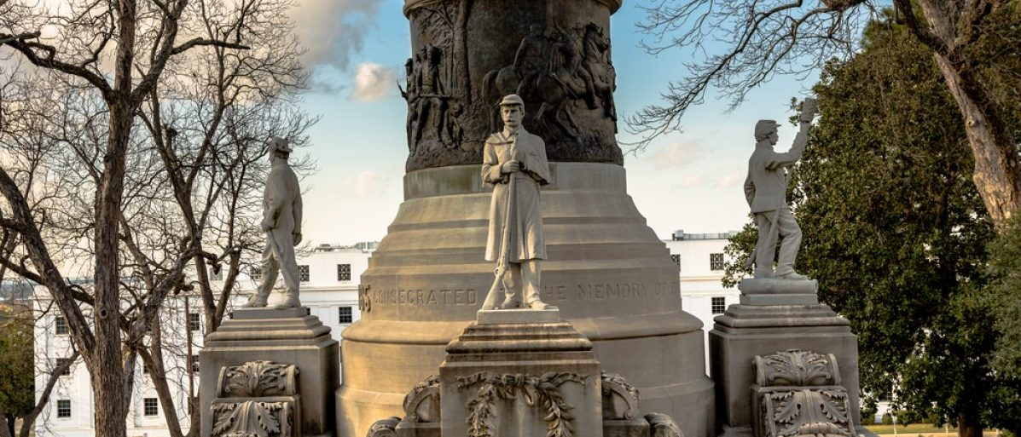 Monument honoring Confederate soldiers in Montgomery, Alabama (Shutterstock/JNix)
Alabama Governor Signs Bill Protecting Confederate Memorials

ROB SHIMSHOCK
http://dailycaller.com/2017/05/25/alabama-governor-signs-bill-protecting-confederate-memorials/
3:05 PM 05/25/2017
Alabama Republican Gov. Kay Ivey signed legislation Wednesday that protects Confederate memorials from removal or modification. Specifically, the law bans the removal or modification of monuments that have been in place for more than 40 years, according to the Associated Press. Schools that have born an individual’s name for more than 40 years can also not be renamed, and a commission must decide whether changes to memorials or schools between 20 and 40 years of age is appropriate.

Ivey’s signature comes following the Alabama Senate’s approval of the bill Friday. Republican Sen. Gerald Allen, the sponsor of the bill, blasted what he described as a “wave of political correctness” against monuments dedicated to those who, despite their flaws, were significant to history. However, Democratic Sen. Hank Sanders said Confederate monuments “represent oppression to a large part of the people in the state of Alabama.” (RELATED: Alabama Legislature Passes Bill Protecting Confederate Memorials)

Alabama’s new law passed five days after New Orleans took down the last of its 4 Confederate memorials.
“[The law] ensures that history is preserved for all generations,” Daniel Sparkman, deputy press secretary for Ivey, told The Daily Caller News Foundation. Sparkman stressed that the law was not about legitimizing discrimination. “This bill is not about protecting discrimination. It’s about making sure that we don’t forget our

mistakes and so that’s why [Gov. Ivey] went ahead and signed this because it’s about protecting our history, not about protecting some people’s history as opposed to others’. It’s about protecting everyone’s history.”
The governor tried to satisfy both Republicans and Democrats with the law by incorporating an amendment, which was approved by the state legislature. The amendment stipulated that schools named after or otherwise dedicated to a person, movement, or military service cannot be renamed without consent from the Committee on Alabama Monument Protection but can be relocated or altered.

Kentucky town welcomes Confederate memorial moved from Louisville
By Bryan Woolston
Reuters May 29, 2017
https://www.yahoo.com/news/kentucky-town-welcomes-confederate-memorial-moved-louisville-041358653.html

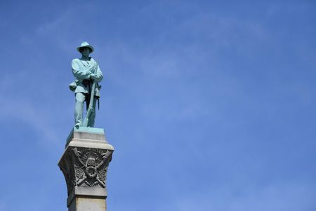otos
A statue of a Confederate soldier stands high above the crowd during a dedication ceremony in Brandenburg, Kentucky, U.S. May 29, 2017 for a Civil War Confederate Soldier Memorial recently removed from the campus of the University of Louisville. REUTERS/Bryan Woolston

By Bryan Woolston
BRANDENBURG, Kentucky (Reuters) - A small Kentucky town gave a formal welcome on Monday to a monument to the Confederate soldiers of the American Civil War, rededicating the controversial structure after the University of Louisville removed it as an unwelcome symbol of slavery. About 400 people, some dressed in grey replica uniforms and many holding small Confederate battle flags, gathered for the Memorial Day ceremony on a bluff above the Ohio River in Brandenburg, about 40 miles (64 km) southwest of Louisville.

The town embraced the tower at a time when Confederate symbols are being removed across the South as reminders of a legacy of slavery and the racism that underpinned it. “The way I look at it, it’s part of our history," Brandenburg Mayor Ronnie Joyner said at the dedication, which included the firing of a Civil War-era cannon. "We need to preserve our history." Brandenburg says the riverfront park where it holds a biennial Civil War reenactment was an appropriate setting for what some see as a respectful homage to Kentucky's fallen.

The monument's new home is near the spot where a Confederate general in 1863 launched a raid on neighboring Indiana, and Brandenburg hopes the addition will bring more tourists to the town. "The Civil War is not a popular part of people’s past, but you can’t wipe it out," said Charles Harper of Louisville, who came to the dedication dressed in Confederate uniform. "Just because you wiped out a reference to the Civil War doesn’t mean you’ve wiped out slavery, doesn’t mean you wipe out racism."

The 70-foot-tall concrete plinth features an oversized statue of a rebel soldier at its crown, representing one of thousands of Kentuckians who fought with breakaway Southern states in the bloodiest conflict in U.S. history.

Monday's ceremony, watched by a crowd that was almost exclusively white, marked the end to a year-long
saga that began in April 2016 when the University of Louisville announced it would dismantle the monument, erected in 1895.

Students and faculty had long criticized the memorial as a tacit tribute to Confederate cause during the 1861-65 conflict, fought primarily over the issue of slavery. Last May, a state judge ruled against some Louisville residents and descendants of Confederate soldiers who sued to keep the monument from being moved.
Kentucky was neutral during the Civil War and never joined the Confederacy. But slavery was legal in the commonwealth and many Kentuckians sympathized with the rebel cause and fought on its side.

The drive to remove Confederate statues in the South and elsewhere accelerated after the 2015 murder of nine African-Americans by an avowed white supremacist at an historic South Carolina church. The murders stirred national soul-searching about racism and its symbols. Soon after the killings, the Confederate battle flag was removed from the grounds of the South Carolina state capitol.

Last week New Orleans dismantled the last of four Confederate statues that stood in the city for decades. The mayor of Baltimore said on Monday that her city was considering following the lead of New Orleans by removing its monuments.

May 23, 12:22 PM EDT
'FLY THE FLAG'? RIFT IN MISSISSIPPI OVER CONFEDERATE SYMBOL
BY EMILY WAGSTER PETTUS
ASSOCIATED PRESS

http://hosted.ap.org/dynamic/stories/U/US_CONFEDERATE_FLAG_MISSISSIPPI?SITE=AP&SECTION=HOME&TEMPLATE=DEFAULT&CTIME=2017-05-23-12-22-08

BILOXI, Miss. (AP) -- As a warm breeze wafts in from the Gulf of Mexico, Carol Mize paces across the street from Biloxi's white marble City Hall. In one hand, she carries a Mississippi flag and in the other, a sign with the slogan: "Fly the flag, Mayor." Both the flag and the sign prominently display the Confederate battle emblem, which caused a rift for generations between those who say it represents Southern heritage and those who call it racist. Discussion of the emblem has stirred Mize's passion as Biloxi finds itself the latest front line in a broad regional dispute over Confederate symbols after the mayor recently ordered the state flag to be pulled from city buildings. "This flag right here had nothing to do with slavery," insists Mize, 55, who says she's also been protesting the removal of Confederate monuments in New Orleans.

The assertion puts Mize - and the other protesters keeping a nearly daily vigil outside City Hall - at odds with many historians and opponents of the banner that Mississippi has flown since 1894. It's the last state flag in the nation that prominently features the Confederate battle emblem - a red field topped by a tilted cross dotted with white stars. Like many symbols of the Old South, the Mississippi flag has come under intense scrutiny since June 2015, when an avowed white supremacist killed nine black worshippers at a Charleston, South Carolina, church. The man, Dylann Roof, had posed for photos holding the rebel flag. Mississippi voters chose to keep the state flag in a 2001 election. Since the Charleston shooting, Mississippi legislators have declined to change the design, with the governor saying voters should decide the issue if it is reconsidered.

The debate this time around is different from the one in 2001. Instead of waiting for a top-down decision, many cities and counties and all eight public universities have acted on their own to remove the flag from display since 2015. The capital city - Jackson, with a majority-black population - furled it years earlier. Biloxi is the latest and one of the largest cities to act. Republican Mayor Andrew "FoFo" Gilich ordered the flag removed from city buildings in April, saying he believes the Confederate emblem makes people feel unwelcome. He said he'd intended to fly only the American flag at city buildings once in office, but the state flag still fluttered in some places. Gilich, seeking a second term in June, was asked about it at a candidate forum hosted by the NAACP.
Hospitality is important in Biloxi, a diverse city that is home to an Air Force base and has an economy heavily dependent on tourists who gamble in casinos and sunbathe on white-sand beaches.
"This is a gumbo of opinions and experiences," Gilich said of Biloxi. "I wanted to make sure, as mayor, that everybody feels welcome."

Gilich, 69, was born and raised in Biloxi and speaks with the distinctive regional accent similar to the New

Orleans mélange of Brooklyn-meets-the-Deep South. Before taking public office two years ago, Gilich ran a software company that managed school-lunch information systems. Gilich's flag decision immediately sparked a backlash. Protesters showed up at City Council meetings. Councilman Robert Deming II proposed an ordinance to require the state flag to fly at all municipal buildings.

A vote on that ordinance is scheduled for Tuesday but could be delayed if city officials seek guidance from the state attorney general about whether Mississippi law even allows a council to consider such a proposal, Republican Councilwoman Dixie Newman said. Deming said there's lots of "drummed-up opposition" to the flag, and that he's heard from a variety of people, including black and Asian residents, who support it. "If a politician can unilaterally take down the state flag if he disagrees with something, then he can take down the American flag if he disagrees with something," Deming said.

Democrat Felix Gines, the only African-American on Biloxi's seven-member council, calls Deming's proposal "a punch in the gut" and wants Mississippi to revert to a previous flag featuring a magnolia tree. "We need a symbol that brings us all together," Gines said.

Michael Cavanaugh, a white attorney, grew up in Biloxi, graduating from a Catholic high school in 1967. The mascot was the Rebels; students waved the Confederate battle flag while the band played "Dixie." Cavanaugh says that was an innocent expression of school spirit, but he now views the Confederate battle emblem as bad for business. "It was hijacked by the Klan, neo-Nazi groups, skinheads, white supremacists and people like Dylann Roof," said Cavanaugh, who supports the mayor's decision.

Others view the flag with less intensity.

Alex and Kendra Winnick of Meridian, Mississippi, were vacationing in Biloxi with their 1-year-old. The African-American couple, sitting on a beach near the landmark Biloxi lighthouse, said they barely notice the state flag, though they understand older African-Americans find it offensive.

"We don't pay attention to it because we're a younger generation," Kendra Winnick said.

With Confederate flags gone, Civil War museum will close

Steve Burns
The Atlanta Journal-Constitution
Wednesday, May 24, 2017 Atlanta News
http://www.ajc.com/news/local/with-confederate-flags-gone-civil-war-museum-will-close/ogScTPPdqliC0z4opJ3GTI/
A Civil War museum in metro Atlanta plans to close. (Credit: Channel 2 Action News)

A Henry County commissioner requested a few months ago that a local Civil War museum remove its Confederate flags. But without that symbol, the Nash Farm Battlefield and Museum announced that it can’t conduct its mission properly and will close June 1.

In a Facebook post, the museum’s directors cited the request by District 2 Commissioner Dee Clemmons that all Confederate flags be removed from the museum, in addition to the gift shop, “in an effort not to offend anyone.” “To exclude any Confederate flag would mean the historical value has been taken from our exhibits, and a fair interpretation could not be presented to each guest,” the post read. “Confederate flags were on this hallowed ground, as were the Union flags. To remove either of them would be a dishonor.”

The museum property, which is owned by the county, included a large collection of artifacts and exhibits that were owned by private citizens. “Henry County in no way asked them to remove their things,” county spokeswoman Melissa Robinson told Channel 2 Action News. “We did not request that. It was a voluntary move to leave the museum.”

The action comes as sentiment against the public display of the Confederate flag is causing similar changes elsewhere in the South. New Orleans recently removed four monuments to Confederate leaders.

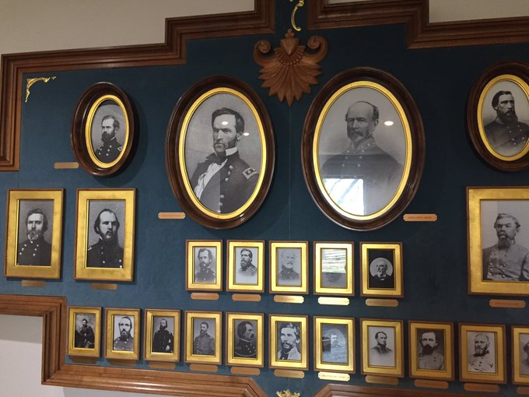
Civil War artifacts removed from Henry County museum linked to dispute over Confederate flag.

But the change in Henry County was not received well by some residents. “You have a museum in this time period to honor both Union and Confederate veterans,” Chuck Johnson said. “No matter which side they fought on, they were all Americans.”

