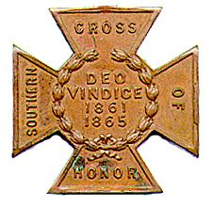
The SOUTHERN CROSS
Newsletter of the Sterling Price Camp #145
Sons of Confederate Veterans
St. Louis, MO
May 2017

Charge to the Sons
“To you Sons of Confederate Veterans, we will submit the vindication of the cause for which we fought. To your strength will be given the defense of the Confederate soldier’s good name, the guardianship of his history, the emulation of his virtues, the perpetuation of those principles he loved and which made him glorious and which you also cherish. Remember it is your duty to see that the true history of the South is presented to future generations.”
General Stephen Dill Lee

Camp Officers

Commander – Ray Cobb
First Lt. Commander – Bob Kennedy Second Lt Commander – Bill Napier
Sgt. at Arms – Dan Maltman Adjutant – Chuck Knight

Camp CALENDAR

Saturday May 6, 2017 Sterling Price Camp meeting cancelled
Sunday May 21, 2017 Utz Camp and MOSB Memorial Day Service at Fee Fee Cemetery at 1:00 PM This year main speaker will be Bob Arnold.

May 27, 2017 Rededication of the monument to Missouri Confederates and Federals Vicksburg National Park , Mississppi. This is the Memorial Day weekend PLEASE consider making this trip to Vicksburg. The Governor of Missouri is supposed to be making the trip.
Saturday, June 3, 2017 Sterling Price Camp meeting
July 18-23, 2017 SCV National Meeting, Memphis, TN

October ?, 2017 The SCV will be breaking ground in October
on THE NATIONAL CONFEDERATE MUSEUM at Elm Springs, TN

Please join us. All monthly meetings are held at the Schnuck’s Supermarket at 12756 Olive Street Boulevard in Creve Couer. It is approximately 1.9 miles west of I-270 on the south side of the street.

See the details under Camp News. Are you interested in presenting at a program, or know of someone who is in 2017, contact Bill Napier, our Program Director.

Camp News
The location of the monthly meeting for the Sterling Price Camp has changed to 12756 Olive Boulevard
in the “Back Stage” Room. Directions from the camp adjutant:

Take the Olive Boulevard exit off INT 270 and go west about one mile until a half a block after you pass Mason Road, then turn left into Bellerive Plaza and at the stop sign make another slight left into the Schnucks parking lot. We have been asked to park near the Firestone Tire Store at the left end of the lot as you face the store. The “Back Stage” room is located inside the front part of the store, on the Firestone store side, about 40 feet beyond the self-checkout counters. Please note: There is prepared food available at the Deli. ONLY FOOD PURCHASED AT SCHNUCKS MAY BE BROUGHT INTO THE ROOM.

Paste the following URL into your browser for a better view:
https://www.google.com/maps/place/12756+Olive+Blvd,+Creve+Coeur,+MO+63141/@38.6787722,-90.4730394,15z/data=!4m5!3m4!1s0x87df2d14080e1c3d:0x44b4099275a4e602!8m2!3d38.6782487!4d-90.4731145?hl=en
The SCV will be breaking ground in October on THE NATIONAL CONFEDERATE MUSEUM at Elm Springs. There will be a plaque at the museum listing all the "founders" that give $1000 toward the museum fund. That’s’ a lot of money so would you consider sending $10, $25 or even $50? The information is in the latest Confederate Veterans magazine. It is also available through the web site.

Confederate Memorial Foundation Association - Dues are $10/year for General Membership, $25/year for Contributing Membership and $55/year for Sustaining Membership. Help support the efforts to maintain the Confederate Veterans Home in Higginsville. Mail to: CMFA, Inc., P.O. Box 332, Higginsville, MO 64037-0332.

Missouri State Guard flags – Here’s your opportunity to be able to fly the flag that was carried by the Missouri State Guard as they defended the state from the unlawful war declared on it by the Federal government in Washington, DC. Those men carried this flag as they marched, fought and died to protect their homes and families from the Federal army under the warmonger Brigadier General Nathaniel Lyon, At Carthage, at Oak hills and over the siege and capture of the fortifications at Lexington she flew and now own your own 3” x 5” replica. They can be purchased via mail order at the price of only $50, which includes taxes and shipping. Send orders to John Moloski, Burnt District Press, P.O. Box 207, Harrisonville, MO 64701. To contact John, call (816) 668-5862.

Southern Cross of Honor Sales - The Moses Wood Camp 125 is selling 26” X 12”crosses made from a composite resin material (similar to a bowling ball) and pigment dyed black. The crosses come with a metal rebar molded into the tang of it making it ready to place upon arrival. The crosses are $30 plus $5 packaging and handling as well as price pf parcel post to your door. Discounts are available on shipping when more than 1 cross is purchased. Contact: Robert E. Little at rmrel1948@yahoo.com. Make checks payable to: Moses Wood Camp 125 SCV, 109 S. Johnson St., Gaffney, SC 29340.

Missouri Division Members Prayer Request

Please continue to pray for 3 members of the M.M. Parsons Camp #178 – Jefferson City, MO

Dizzy Carver - Dizzy has already successfully faced down prostate cancer. It now appears that he may have an even more serious cancer affecting his esophagus. He will be undergoing a series of tests in the coming weeks and a treatment regimen should begin around the first of April.

Jim Chilcutt - Jim has been undergoing treatment for cancer for the third time. He is about 80 years old and has a sharper mind than I ever had even in my best days. That would be the first thing you would notice about him followed very quickly by his clever and sometimes self-effacing sense of humor. His wife Barbara is likewise very sharp-minded, compassionate and ever supportive of Jim.

Camp commander Stan Myers- Last Wednesday he underwent reparative surgery at the University Hospital in Columbia. This was in follow-up to a previous surgery to remove a cancerous growth on his bowel. We are told that he is doing well and may be released from the hospital in 3-4 days. Stan is a fine gentleman and deeply dedicated to the SCV.

We appreciate our members, their family and friends if we can pray for you need of any kind please send them. We will like our Confederate Ancestors lift up these requests to our Lord and Savior.

Thursday, April 13, 2017
Brothers & sisters,
Please pray for Ryan & Misty, very good friends of mine. Misty is having her first baby at the age of 40 after over 12 years of trying. She was induced Tuesday night and has been making slow but steady progress. She reached a point this morning where the pain was too much so, after several hours, they now have her on her third epidural, after the first two failed. She may be having some fever issues, as well. Pray this would be successful and she would soon have her son.

In His service and yours.
Thomas McConnell tom@missouriwoods.com

From Bob Painter, an update on Asheley Erhard:
In December Dave Roper requested Prayer for Jim Erhard's Daughter Ashley, who had been hit by a car. I have been checking on her. She was I serious condition and now has to regain what she can from the accident. She is better and he is grateful for all you prayers.

Jim replied to a recent query:
She seems to be doing well. Asheley has been home in Gastonia NC since the first part of February. She has made a lot of progress. I have spoken with her on the phone numerous times since she has been able to. The conversations at first were not very long, as she was unable to process and coordinate much more that Yes and No to questions. She has really improved on her Cognative abilities as of late. She now is able to navigate her cell phone and has been really busy with friends and family. It is only by the grace of God and many prayers that she has come so far. I will include a photo in this email so you can get a better udea of how far she has come. Thank you again for your time, inquiries and prayers. Myself and Asheley really appreciate you all. Have a blessed day. And Thank You again.

Jim Erhard [mailto:spacecase1369@yahoo. com]

From Travis Archie – Commander, Campbell's Company Camp #2252

Past (and hopefully future) member Travis Franklin's home received significant damage in the F-2 tornado that hit Goodman last night. The family is uninjured but their home sustained terrible damage. Please keep them in your thoughts and prayers.

From Elijah Gate Camp #570 – Fulton - please lift up our brother members in your prayers:
Martin Northway - Past Camp Commander- is in a nursing home in Fulton and is having health issues that will last his entire life; he recently gave up his Editorship of our award-winning newsletter.
Tom Suttles -Camp Chaplain – He has had major reconstructive surgery on his shoulder, and will be facing therapy for a year.

On Thursday, April 27, 2017 8:03 AM, Bob Painter <paint@robertbobpainter.com> wrote:

Merle Doughty the father of Doug Doughty, of the Surgeon John Craven Camp 2276, passed recently, please pray and lift them up in this time. Wesley "Merle" Doughty, age 88, a resident of Chillicothe, Missouri, passed away on Monday, March 13, 2017, at Cameron Regional Medical Center, Cameron, Missouri. He had been a resident of the Cameron Missouri Veterans Home since June 2014.
Doug’s address is: Doug Doughty
4787 Liv. 503
Chillicothe, MO 64601

We appreciate our members, their family and friends if we can pray for your needs, or joy of blessings, with a praise, please send them to us.
Please send prayer requests to your Camp Chaplain and Bob Painter Missouri Division:
Bob Painter
12802 NE Mt. Olivet Road
Kansas City, MO. 64166
816-532-3841
M-816-806-0733
paint@robertbobpainter.com

Rededication of Monuments to Missouri Soldiers at Vicksburg National Park
The monument to Missouri Confederates and Federals -- a rare "joint monument -- at Vicksburg National Military Park is scheduled to be rededicated after major restoration on May 27, 2017. This is on Memorial Day Weekend. Missouri Division Commander Keith Daleen cannot be in attendance due to conflicts and has asked that I attend in his stead... and I will be honored to do so. This rededication will have in attendance, the Governor of the State of Missouri as well as members of the Sons of Union Veterans of the Civil War. It is my belief that we MUST have a significant number of Missouri Confederate Descendants in attendance as well.
At this time, all the details are not known, but it will most likely be a ceremony taking place at around 1:00 p.m. on Saturday - May 27th. More details will be forthcoming as we get them. This is a holiday weekend and many other events are taking place, but I implore you to consider attending this once in a lifetime opportunity to recognize our Missouri Confederate Heroes at Vicksburg. Many of us could car-pool, share motel rooms, etc., in an effort to have a strong showing. Confederate uniforms will most likely be on display so if you have a uniform, the more the better.
We NEED to be there! Please contact Darry Maples if you have any questions or thoughts and PLEASE consider making this trip to Vicksburg.

Notice from the Adjutant-in-Chief:

The General Executive Council (GEC) met in Elm Springs on Saturday, March 11, 2017 and voted, without objection, to change two (2) items which will affect doing business going into the 2017-2018 fiscal Year.
First – As you all know a grace period of 90 days has been afforded to members to renew their dues and not be considered as becoming delinquent on August 1st each year. That period will now change to only 30 days, meaning that a member who fails to renew by September 31st will become delinquent.
Second – Currently we prorate dues for both new and delinquent renewing members. Beginning with the
2017-2018 fiscal year proration will apply to only new members. Delinquent renewing members will no longer be able to prorate.

Sterling Price Camp Meeting Minutes
Sunday, April 1st, 2017 at Schnucks

1. The meeting was called to order by Commander Ray Cobb at 3:00 PM.
2. The invocation was given by 2nd Lt. Commander Bill Napier
3. The Pledge of Allegiance was led by Past Commander Jim England
4. The Salute to the Confederate Flag was led by Eastern Division Commander Mike Harris.
5. Reading of the Last Meeting’s Minutes – A motion was made by 2nd Lt. Commander Bill Napier, then
seconded and passed to dispense with the last meeting’s minutes as they were included in the Camp Newsletter.
6. Adjutant’s Report: A motion was made by 2nd Lt. Commander Napier then seconded and passed to
dispense with the reading of the Financial Report.
7. Announcements, Reports and Information Passed to the Camp:
A. 2nd Lt. Commander Bill Napier gave a report on the results of the “Swap Meet” held at Jefferson Barracks in late March. He indicated there wasn’t a good turn-out and that he only made a small amount on sales. He plans to contact Michael Pierce, the Swap Meet organizer, to persuade him to change the date of the annual event to a later date in the spring, hoping for a better turn-out.
B. Guest Edna Dieterel made a pitch on a planned upcoming event later this year, October 7th, to commemorate the 150th Anniversary of the death and burial in Bellefontaine cemetery of former Governor and General (CSA) Sterling Price, and his daughter-in-law, wife of Celsus Price, and their baby son all who died on the same day and are buried near Gen. Price in Bellefontaine. Edna is looking for volunteers to participate in the re-enactment in period clothing.
8. There were no committee reports.
9. New Business: None
10. Program for the Meeting: The original program scheduled for this meeting “The 1862 River War” which
was to be given by St. Louis City Librarian Tom Pearson who had to cancel due to a scheduling conflict and will give his report at a later date. However, Program Chairman and Second Lt. Commander Bill Napier stepped in and gave a very interesting and informative talk on “Little Egypt” the southern parts of Illinois and Indiana whose populations at the beginning of the War Between the States showed very strong support toward the Confederacy. It was obvious that Compatriot Napier had done a lot of research and study on the subject “Little Egypt” from his presentation.
11. Other Announcements before Closing: The Speaker for the next meeting, Saturday May 6th will be Ret.
U.S. Army major Douglas Gifford whose topic will be: “Logistics in the civil War”. Also, three Camp members will be traveling to Vicksburg, Miss. for the re-dedication of the Missouri War Between the States Monument in the Vicksburg National Military Park on U. S. Memorial Day, Monday May 29^{th.} It has recently undergone restoration. The Governor of Missouri, Eric Grietens, will also be in attendance.
12. The singing of Dixie: - was led by Commander Ray Cobb.
13. Benediction: Compatriot and Past Commander Jim England closed the meeting with a heartfelt reading
of the poem “The Southern Dead”.

HERITAGE DEFENSE

Belleview will fly Confederate flag to honor community history
Posted Apr 24, 2017 at 4:27 PM Updated Apr 24, 2017 at 4:39 PM

Stories from Headlines Network
By Katie Pohlman
http://www.ocala.com/news/20170424/belleview-will-fly-confederate-flag-to-honor-community-history

A third flag will join the U.S. and Florida ones on Wednesday at Belleview’s City Hall to honor Confederate History Day. The third national Confederate flag, also known as the “blood-stained banner,” will be raised to half-staff around 7:30 a.m. to honor Confederate veterans. The local Sons of Confederate Veterans unit has performed this tribute ceremony for more than 10 years. Sons of Confederate Veterans 8th Brigade Commander Chuck Kadel said it is important to recognize all American veterans. “(Confederate veterans) were veterans just as American veterans are,” he said.

April is recognized by the state of Florida as Confederate History Month. A Belleview city proclamation passed April 4, which will be read at the flag raising ceremony, states that Florida supplied the greatest percentage of its population as soldiers compared to all other Confederate states. Further, one-third of the Floridian soldiers did not return from war.

Being the least populous state, Florida provided 15,000 soldiers to fight in the war, 5,000 of which were killed, according to a website called “Exploring Florida,” curated by the Florida Center for Instructional Technology at the University of South Florida. Florida also became the breadbasket of the Confederacy. Farmers sent beef, pork, fish, fruit and salt to keep the meat from spoiling to Confederate soldiers throughout the war, according to the website.

Beginning in summer 2015, after the deadly Charleston church shooting in which a white man shot and killed

nine black people at Emanuel African Methodist Episcopal Church, a debate was sparked about whether the Confederate flag should be flown in front of the McPherson Governmental Complex. Confederate flags across the country were pulled down in the aftermath of the shooting. Demonstrations by groups both for and against flying the flag and community debates filled the months afterward. The flag was removed in May 2016.

The Marion County Commission approved a proclamation April 4 acknowledging Confederate Memorial Day.
Belleview Mayor Christine Dobkowski said the city has never heard any formal complaints about flying the Confederate flag. She said acknowledging Confederate History Day and Month is historically important to the city of Belleview. “It’s part of the history of our community,” she said.

And HERITAGE HATE

New Plan to Remove Confederate Monument in Forest Park
April 24, 2017 4:05 PM By Kevin Killeen
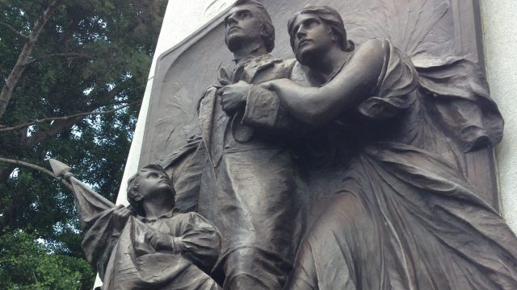

ST. LOUIS (KMOX) – While the city of New Orleans is removing its Confederate statues, a 32-foot tall monument to Confederate soldiers here in Forest Park still stands — two years after the Slay Administration began exploring how to remove it. Now the point man on the project, Human Services Director Eddie Roth, is preparing to brief new Mayor Lyda Krewson on where the project stands.

“The most economical and preferred plan is one that would cost about $100,000,” Roth says. “It mainly involves burying the granite shaft in place in Forest Park where it will be preserved.” Under the plan, the bronze face plate would be removed and stored someplace else. Roth says his research of the monument, placed in St. Louis in 1914 by the Daughters of the Confederacy, shows it was part of a revisionist history trend in many cities. Roth is scheduled to meet with Krewson about the monument in May.

Dave Roper’s email read “We must contact Mayor Lyda Krewson before Eddie Roth gets a hold of her. He is just a Slay wannabe. Her phone number is 314-622-3201. I don’t have a regular email address but if you do a search on your computer type in Homepage I Office of the Mayor, City of St. Louis. Her Mayor’s Office web page will come up. There is the way to email her. If anyone has her email address please share. Remember to be nice and just tell her how you feel about this. I’ am going to tell her I will “Boycott” St. Louis City that means the Blues and Cards and anything else if they do anything to the Monument. If you live out of town tell her that when there you stay at a hotel. Please send this to everyone you know.”

Also, we need to bombard these folks requesting they move forward with H.B. 53, The Missouri Heritage Protection Act. Time is running out for this year. Please forward to all Confederate sympathizers.
Yes, EVERYONE CALL OUR LEGISLATURES:

Speaker of the House Todd Richardson todd.richardson@house.mo.gov

Speaker Pro Tem elijah.haahr@house.mo.gov

Majority Floor Leader mike.cierpiot@house.mo.gov

Asst. Majority Floor Leader kevin.austin@house.mo.gov

Veterans Committee Chair Charlie.davis@house.mo.gov

Apr 24, 5:58 AM EDT
APNewsBreak: New Orleans to take down Confederate statues
By JESSE J. HOLLAND
Associated Press
http://hosted.ap.org/dynamic/stories/U/US_CONFEDERATE_STATUES_NEW_ORLEANS?SITE=MYPSP&SECTION=HOME&TEMPLATE=DEFAULT&CTIME=2017-04-24-02-39-51
Workers in New Orleans began removing the first of four prominent Confederate monuments early Monday, the latest Southern institution to sever itself from symbols viewed by many as a representation racism and white supremacy.
Trucks arrived to begin removing the first memorial, one that commemorates whites who tried to topple a biracial post-Civil War government in New Orleans, around 1:25 a.m. in an attempt to avoid disruption from supporters who want the monuments to stay, some of whom city officials said have made death threats.
Workers who were inspecting the statue ahead of its removal could be seen wearing flak jackets and helmets. Police officers watched the area from atop the parking garage of a nearby hotel.
Three other statues to Confederate Generals Robert E. Lee and P.G.T. Beauregard and Confederate States of America President Jefferson Davis will be removed in later days now that legal challenges have been overcome.
"There's a better way to use the property these monuments are on and a way that better reflects who we are," New Orleans Mayor Mitch Landrieu said in an interview Sunday with The Associated Press.
The American Confederacy is still alive in a small Brazilian city called Americana
Melia Robinson
http://www.businessinsider.com/photos-us-confederacy-americana-brazil-2017-5/#each-year-the-small-brazilian-city-of-americana-throws-a-huge-celebration-to-commemorate-the-10000-confederates-who-fled-the-american-south-after-their-side-lost-the-civil-war-1
When the American Confederacy lost the Civil War in May 1865, 10,000 Southerners fled the US for a small city in Brazil, where they could rebuild their lives and carry on their traditions. Now, 150 years later, their story has been seemingly erased from the history books. But deep in the heart of Brazil, descendants of these confederate expats gather annually to celebrate their controversial history and maintain their traditions and culture.
.
Each year, the small Brazilian city of Americana throws a huge celebration to commemorate the 10,000 Confederates who fled the American South after their side lost the Civil War They settled in Americana in the Brazilian state of São Paulo, which remains a sort of enclave for the long-dead expats' descendants.

For the 2,000 Brazilians in attendance, the American South is part of their heritage. The "Confederados" don't appear in most history books. But 150 years ago, people from Texas, Alabama, and Georgia sailed to Brazil in hopes of preserving the ways of the unreconstructed South.

Brazil welcomed the defectors. For years, it had tried and failed to catch up with agricultural development in the US. Emperor Dom Pedro II of Brazil hoped to plant the seeds of prosperity by importing these self-exiling Southerners.

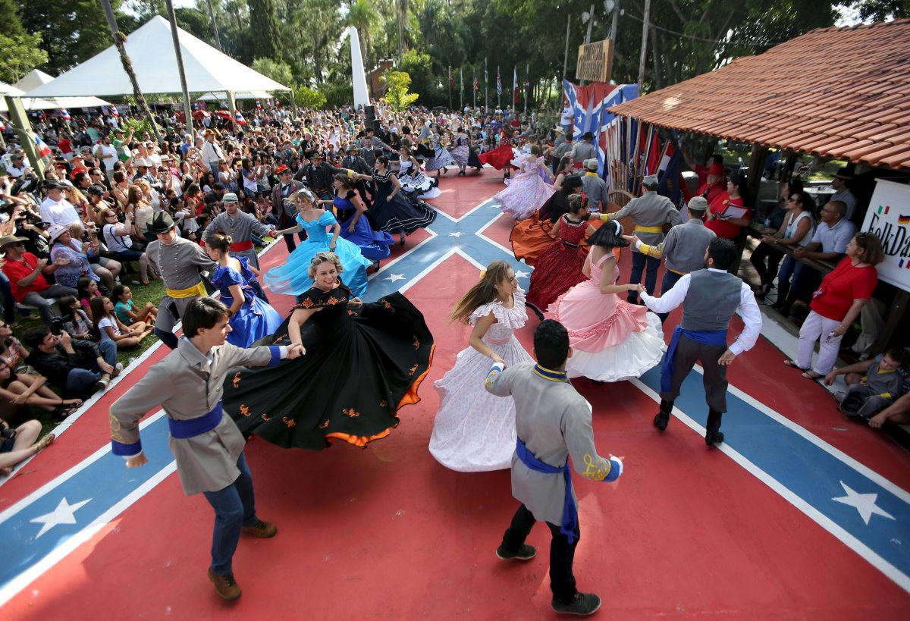
Paulo Whitaker/Reuters
.
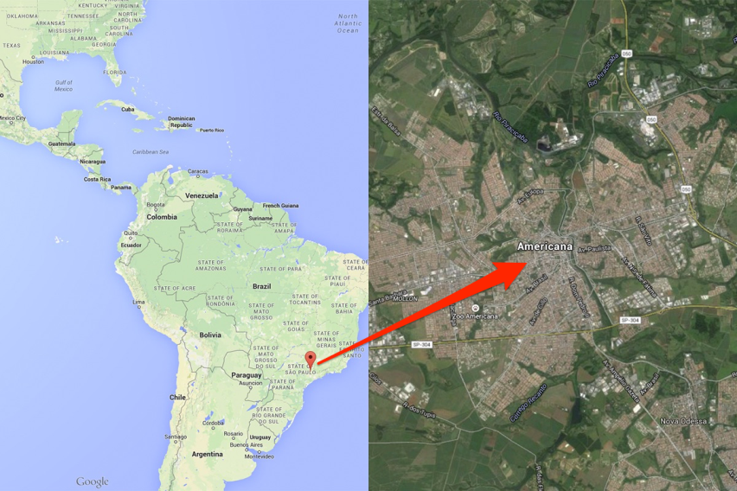
The Brazilian government set up informational agencies across the Bible Belt and offered to pay relocation costs for all Americans willing to make the move. Confederates saw emigration as an opportunity to rebuild their lives. In Brazil, they could buy land on the cheap and rebuild their plantations with the help of then-legal slaves.
More than 10,000 Americans fled for this promising new world, but many failed to adjust. They planted crops that wouldn't grow in Brazil's tropical climate. The circumstances forced many to move to cities and abandon their dreams of owning plantations.

However, one group of settlers led by a colonel from Alabama introduced cotton to the countryside of São Paulo, Brazil. Their tribe flourished. In the little community they named Americana, the children spoke English with a Southern accent for generations. They eventually married into the local population.
The population grew to 200,000, and their Brazilian identity took over. Their American heritage was reduced to Western movies and country music, which they still enjoyed.

For the last 25 years, the descendants of the Confederados gather for the annual "festa" of the Fraternidade Descendência Americana, a sort of brotherhood. Brazilians account for most attendees, although the party will draw Confederate enthusiasts from as far as Georgia, Tennessee, and Virginia. The men often wear gray Rebel uniforms. And the women twirl in kitschy handmade hoop skirts. Couples dance across a Confederate flag-painted stage to the sounds of battle hymns, country music, fiddles, and banjos. Beer, burgers, fried chicken, and Southern barbecue fuel partygoers into the night.

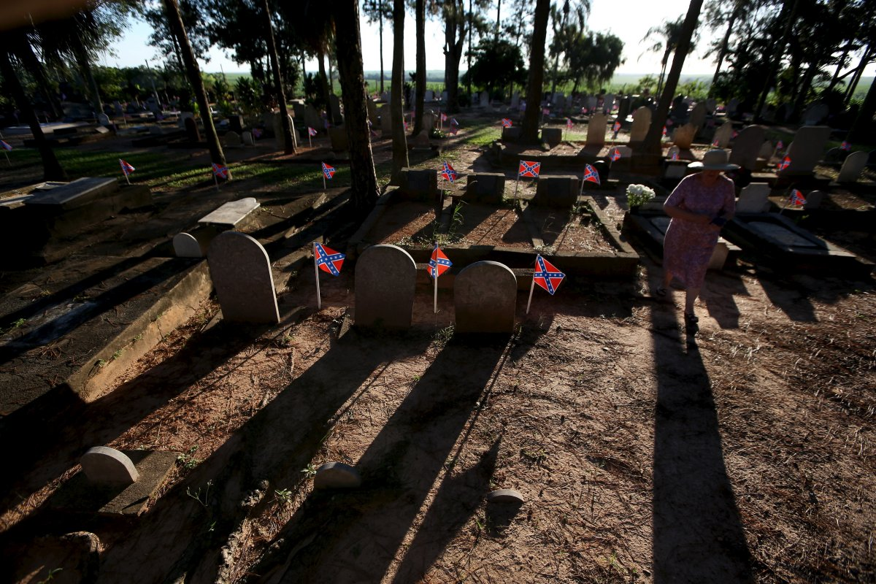
Noemia Pyles, a descendant of American Southerners, walks in a cemetery where
American Southern immigrants are buried in tombs adorned with the Confederate flag.
Paulo Whitaker/Reuters

It's customary to visit a graveyard in the middle of a sugarcane field where Confederate flags mark the graves of the early immigrants. Many of the tombstones say something like, "Born: Texas. Died: Brazil."

A monument immortalizes the names of the first families who settled in Americana.
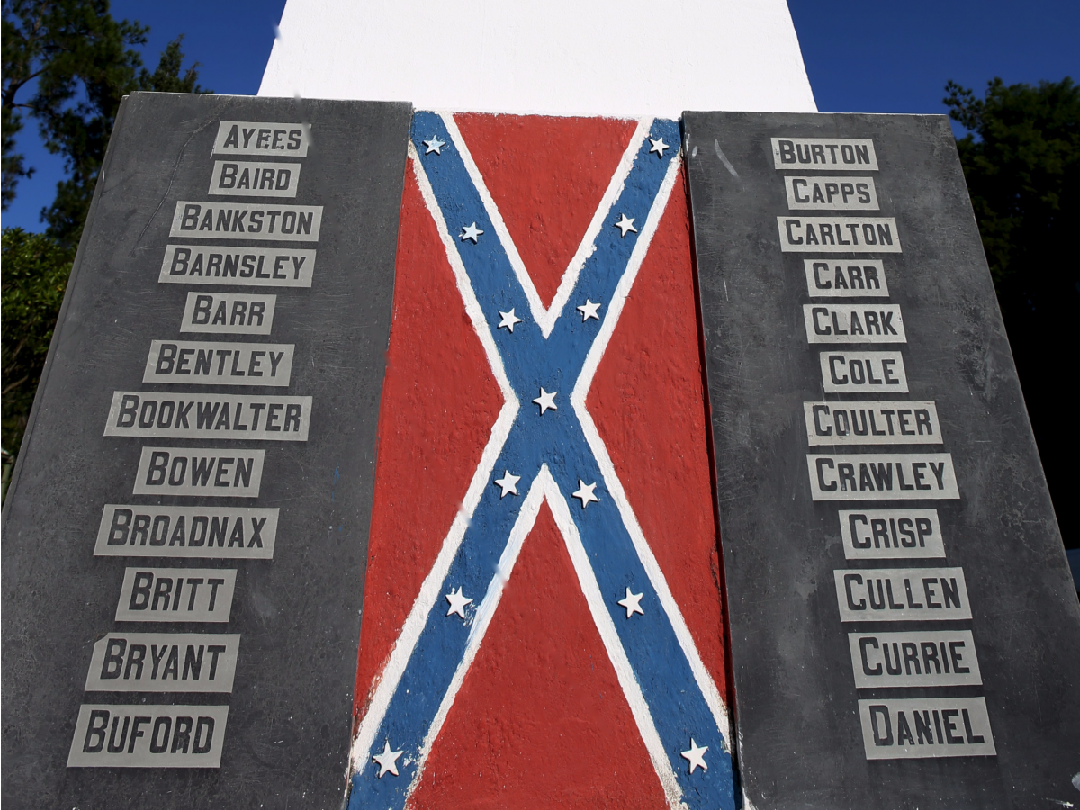
Paulo Whitaker/Reuters
Today, their descendants look upon the Confederate flag not as an emblem of racism and slavery but as a symbol of something their ancestors held dear to their hearts.

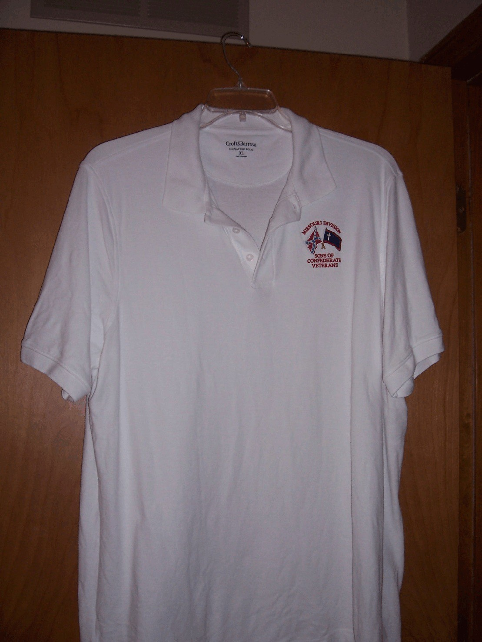

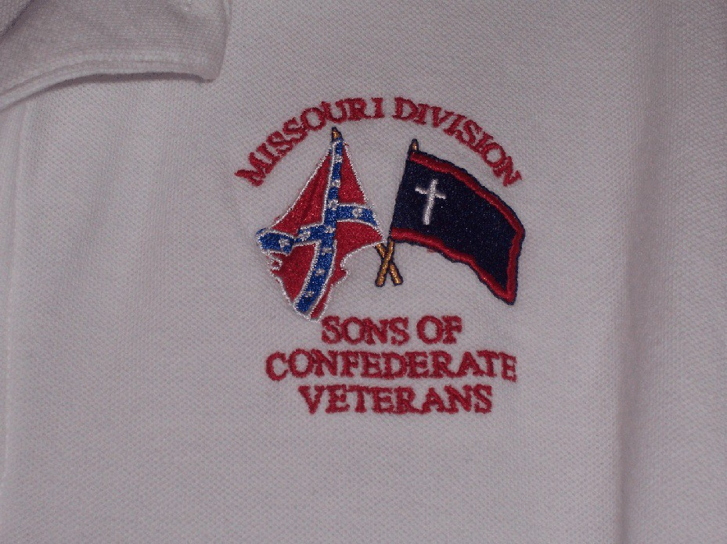

Missouri Division Confederate Flag Polo Shirt Order Form

Name or Camp Name/Number: ________________________________________________

Contact Person: ________________________________________________

Phone Number: ________________________________________________

Email: ________________________________________________

Shirts are available in White/Gray/Tan

Number of Shirts:__________ Size:__________ Color:__________ Total Cost:$_________

Number of Shirts:__________ Size:__________ Color:__________ Total Cost:$_________

Number of Shirts:__________ Size:__________ Color:__________ Total Cost:$_________

Number of Shirts:__________ Size:__________ Color:__________ Total Cost:$_________

Number of Shirts:__________ Size:__________ Color:__________ Total Cost:$_________

Number of Shirts:__________ Size:__________ Color:__________ Total Cost:$_________

All orders can be sent to:

Darrell Maples, 2416 Iven Rd., Jefferson City, MO 65101. Best to do
as a "Camp order" with all ordered at one time, and a mailing address to
send the shirts to. Checks made to MO Division - SCV.

* Use Back of Form if necessary

